**Assignment-3**

# **Importing required lib**

# [ ] import cv2

# import numpy as np

import matplotlib.pyplot as plt

# **Create black image**

[ ] img1 = np.zeros((400,600,3),np.uint8)

plt.imshow(img1)

<matplotlib.image.AxesImage at 0x7fc494447490>

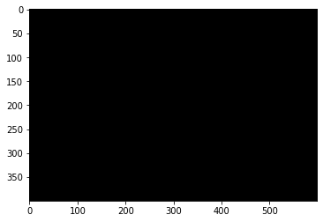

**Drawing functions**

[ ] # Drawing circle

circle = cv2.circle(img1,(300,200),50,(255,0,0),-1) #(0,0,0)-->(R,G,B)

plt.imshow(img1)

<matplotlib.image.AxesImage at 0x7fc494252ad0>

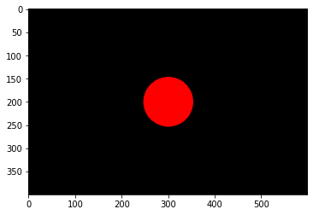

[ ] # Drawing rectangle

rectangle = cv2.rectangle(img1,(200,100),(400,300),(0,255,0),5)

plt.imshow(img1)

<matplotlib.image.AxesImage at 0x7fc4941d9fd0>

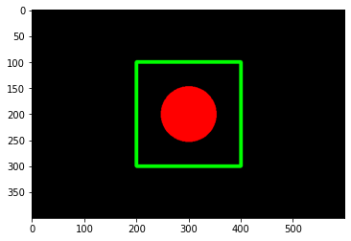

[ ] # Drawing lines

line1 = cv2.line(img1,(200,100),(400,300),(0,0,255),5)

line2 = cv2.line(img1,(400,100),(200,300),(0,0,255),5)

circle = cv2.circle(img1,(300,200),50,(255,0,0),-1)

plt.imshow(img1)

<matplotlib.image.AxesImage at 0x7fc494055210>

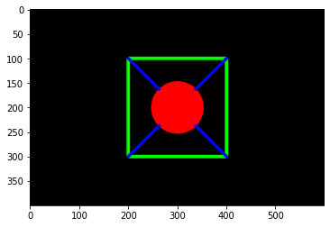

[ ] # Writing text on image

text = cv2.putText(img1,'OpenCV',(200,50),cv2.FONT_HERSHEY_SIMPLEX,2,(255,255,255),5)

plt.imshow(img1)

<matplotlib.image.AxesImage at 0x7fc4940b4550>

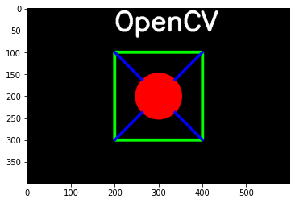

[ ] # Save the image

cv2.imwrite('output.jpg',img1)

True

[ ] # Reading the image

img = cv2.imread('/content/cat.jpg')

plt.imshow(img)

<matplotlib.image.AxesImage at 0x7fc4935bfe10>

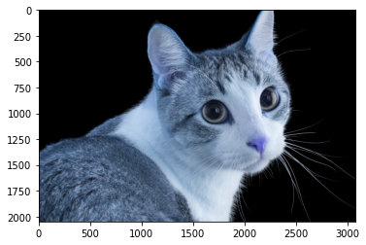

[ ] # Converting color (BGR to RGB)

img_rgb = cv2.cvtColor(img,cv2.COLOR_BGR2RGB)

plt.imshow(img_rgb)

<matplotlib.image.AxesImage at 0x7fc4935431d0>

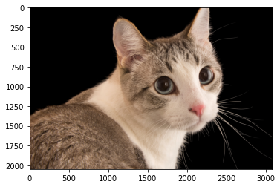

[ ] # Converting color (BGR to Gray)

img_gray = cv2.cvtColor(img,cv2.COLOR_BGR2GRAY)

plt.imshow(img_gray)

<matplotlib.image.AxesImage at 0x7fc492cd9650>

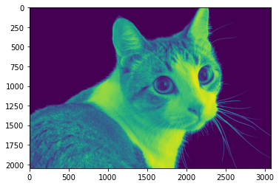

[ ] # Visualizing the shape

img_rgb.shape

(2048, 3072, 3)

[ ] # Reshape image

img_resize = cv2.resize(img_rgb,(500,400))

plt.imshow(img_resize)

<matplotlib.image.AxesImage at 0x7fc492cb5050>

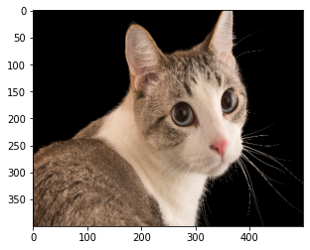

[ ] # Rotate image

img_rotate = cv2.rotate(img_resize,cv2.ROTATE_90_CLOCKWISE)

plt.imshow(img_rotate)

<matplotlib.image.AxesImage at 0x7fc492c0c650>

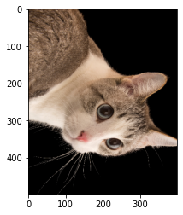

[ ] # Image crop

img_crop = img_resize[175:220,250:300]

plt.imshow(img_crop)

<matplotlib.image.AxesImage at 0x7fc48a417390>

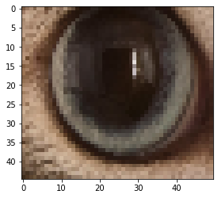

[ ] # Image Blur

img_blur = cv2.GaussianBlur(img_resize,(11,11),cv2.BORDER_ISOLATED)

plt.imshow(img_blur)

<matplotlib.image.AxesImage at 0x7fc48a21c490>

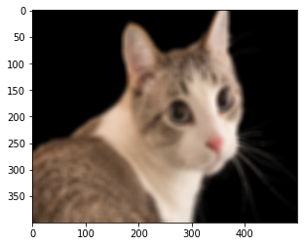

[ ] # Creating Border

im=cv2.copyMakeBorder(img_crop,5,5,10,10,cv2.BORDER_CONSTANT)

plt.imshow(im)

<matplotlib.image.AxesImage at 0x7fc48a1fb4d0>

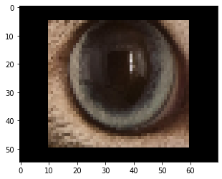

[ ] # Edge detection

img_canny = cv2.Canny(img_resize,20,20)

plt.imshow(img_canny)

<matplotlib.image.AxesImage at 0x7fc489fb9d90>

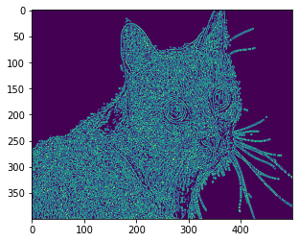

[ ] # Edge detection

img2 = cv2.imread('/content/Hyundai_KONA-EV_Side-Profile_640x331.png')

img2_canny = cv2.Canny(img2,150,150)

plt.imshow(img2_canny)

<matplotlib.image.AxesImage at 0x7fc48a0e3050>

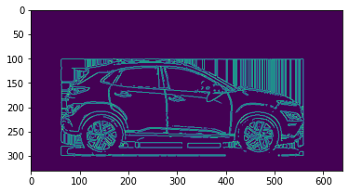

[ ] plt.imshow(img2)

<matplotlib.image.AxesImage at 0x7fc48a4dba10>



 